Exercise 3: Stored Procedures
Scenario 1:
The bank needs to process monthly interest for all savings accounts.
Programs 1:
CREATE OR REPLACE PROCEDURE ProcessMonthlyInterest IS
BEGIN
UPDATE Accounts
SET balance = balance + (balance * 0.01)
WHERE account_type = 'Savings';

COMMIT;
DBMS_OUTPUT.PUT_LINE('Monthly interest processed for Savings accounts.');
END;

Program 2:
BEGIN
ProcessMonthlyInterest;
END;

Output:

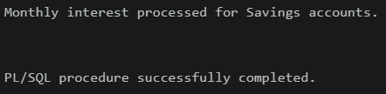

Scenario 2:
The bank wants to implement a bonus scheme for employees based on their performance

Program 1:
CREATE OR REPLACE PROCEDURE UpdateEmployeeBonus(
p_department IN VARCHAR2,
p_bonus_percentage IN NUMBER
) IS
BEGIN
-- Calculate and add the bonus based on the parameters passed
UPDATE Employees
SET salary = salary + (salary * (p_bonus_percentage / 100))
WHERE department = p_department;

COMMIT;
DBMS_OUTPUT.PUT_LINE('Bonus of ' || p_bonus_percentage || '% applied to the ' || p_department || ' department.');
END;

Program 2:
BEGIN
UpdateEmployeeBonus('IT', 5);
END;

Output:

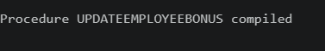
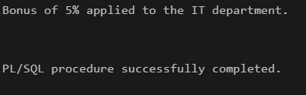

Scenario 3:
Customers should be able to transfer funds between their accounts.

Program 1:
CREATE OR REPLACE PROCEDURE TransferFunds(
p_from_account IN NUMBER,
p_to_account IN NUMBER,
p_amount IN NUMBER
) IS
v_current_balance NUMBER;
BEGIN
-- 1. Check the balance of the source account
SELECT balance INTO v_current_balance
FROM Accounts
WHERE account_id = p_from_account;

IF v_current_balance >= p_amount THEN

UPDATE Accounts
SET balance = balance - p_amount
WHERE account_id = p_from_account;

UPDATE Accounts
SET balance = balance + p_amount
WHERE account_id = p_to_account;

COMMIT;
DBMS_OUTPUT.PUT_LINE('SUCCESS: Transferred $' || p_amount || ' from Account ' || p_from_account || ' to ' || p_to_account);

ELSE
DBMS_OUTPUT.PUT_LINE('FAILED: Insufficient funds in Account ' || p_from_account);
END IF;

EXCEPTION
WHEN NO_DATA_FOUND THEN
DBMS_OUTPUT.PUT_LINE('ERROR: One or both account IDs do not exist.');
WHEN OTHERS THEN

ROLLBACK;
DBMS_OUTPUT.PUT_LINE('CRITICAL ERROR: Transaction rolled back to maintain data integrity.');
END;

Program 2:
BEGIN
TransferFunds(103, 101, 1000);
END;

Output:
